Most of the company asking do you have any knowledge in scripting languages?

**Python in DevOps**

**What is Python?**

Python is a programming language.

Eg: Python, C, C++, java, Php, Perl, Ruby, java script, Go.

If we want to communicate with **hardware**, the **hardware** only understands **0s and 1s**. So, we need to learn a **programming language** to bridge this gap. Since I know Python and hardware understands binary (0s and 1s), there needs to be a translator between them. This translator is either a compiler or an interpreter.

**Summary of difference between Interpreter and compiler**

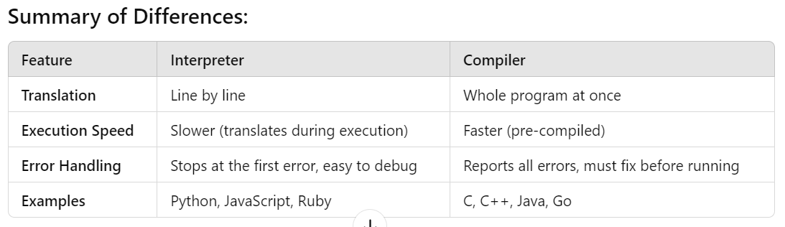

Notes, Python 3 was running till date, that was built in 2008.Now they upgraded the version on 3.

**FYI: Windows Xp --> python 3.2 ., windows 7🡪python 3.5 ., win 10,11 🡪Python Latest.**

**1.Keywords:**

**Python** is a case-sensitive language, meaning that it distinguishes between uppercase and lowercase letters.

**Example: False,** is**,** return**, None**, for**, True,** def **,** while **,** and **,**del, not **,** elif **,** if **,** or **,** else, import**.**

2.**Variables:**

**Rules:**

If you want to create a variable in python language tool we have some rules, the rules are below.

**Rule 1:** Your variable starts with Alphabets or underscore (**a-z, A-Z** or **_**)

**Rule 2:** Your variable Can be a combination of Alphabets, Underscore and Number.

**Rule 3:** Cannot be a Key word.

**3. Data Types**

There are four types of data bases.

1.Integer – 1, 1244, -1234

2.Float- 1.0, 123.324, -566898.76

3.String – “Hello world”, “a”, ‘a’

4.boolean –True, False

**4. Print () - function**

The print () function prints the specified message to the screen, or other standard output device. The message can be string, or any other object, the object will be converted into a string before written to the screen.

**# type () – python standard function**